**Table of Contents – Release 4**

**SECTION 1. CHILDHOOD MENTAL HEALTH DIAGNOSIS (Pg 2)**

* 1. Percent of TN Children with Any Reported Mental Health Diagnosis

1.2 Parent- Reported Diagnosis of ADHD, Anxiety, or Depression in TN Children Over

Time

**SECTION 2. CHILDHOOD MENTAL HEALTH SERVICES (Pg )**

2.1Percentage of TN Children with a Mental Health Diagnosis Receiving Mental Health Services

2.2 Mental Health Service Use Among TN Children with Depression, Anxiety, ADHD/ADD, or Autism

**SECTION 3. SCHOOL-BASED MENTAL HEALTH SERVICE USE (Pg )**

3.1 Trend in School-Based Mental Health Service Use Among TN children Receiving Mental Health Services

**SECTION 4. ABOUT THE VANDERBILT CHILD HEALTH POLL (Pg )**

**SECTION 1. CHILDHOOD MENTAL HEALTH DIAGNOSIS**

* 1. **Percent of TN Children with Any Reported Mental Health Diagnosis**

For the sixth year in a row, more than a quarter of TN parents polled reported that their child has been diagnosed by a medical professional with a mental health condition.

|  |  |
| --- | --- |
| **Year** | **Percent** |
| 2024 | 30% |
| 2023 | 31% |
| 2022 | 35% |
| 2021 | 33% |
| 2020 | 32% |
| 2019 | 29% |

**1.1 Percent of TN Children with Any Reported Mental Health Diagnosis**

* 1. **Parent- Reported Diagnosis of ADHD, Anxiety, or Depression in TN Children Over Time**

Of the diagnoses reported by TN parents for their children, we see prevalence of ADHD, Anxiety, Depression, and Autism diagnoses remaining above the national average. There has been some decrease in prevalence of Depression and Anxiety compared to 2023. Prevalence of ADHD remains at the highest levels reported since 2020. For Autism, reported prevalence rates of Autism in children of TN parents polled were double the national average.

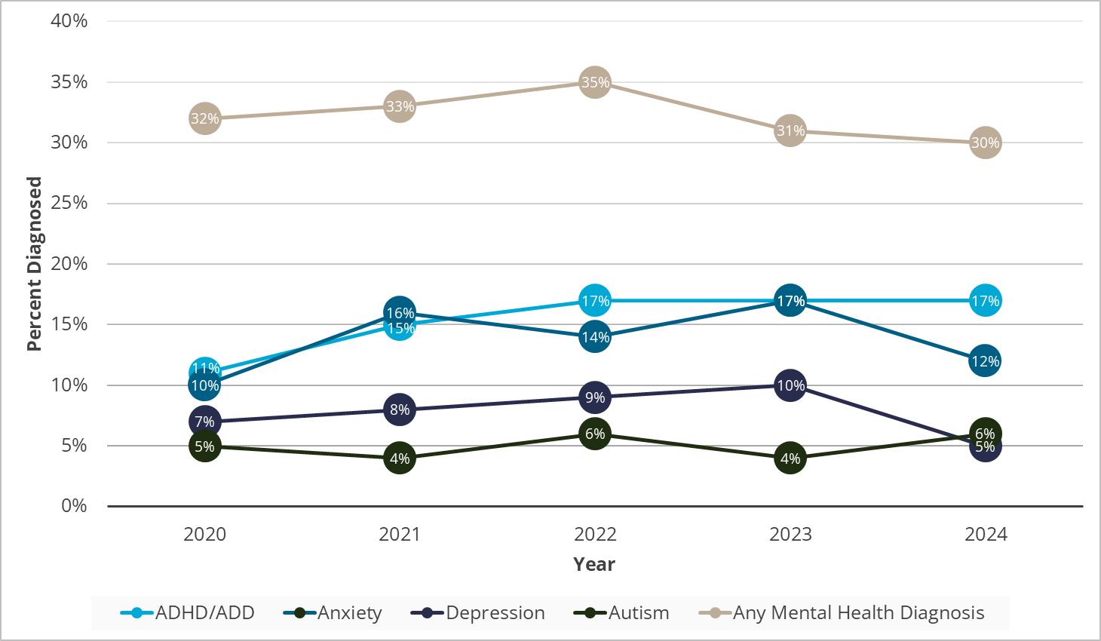

**1.2 Parent- Reported Diagnosis of ADHD, Anxiety, or Depression in TN Children Over Time**

**SECTION 2. CHILDHOOD MENTAL HEALTH SERVICES**

**2.1 Percentage of TN Children with a Mental Health Diagnosis Receiving Mental Health Services**

Less than half of children with a diagnosed mental health condition are receiving mental health services or treatment represented by TN parents polled.

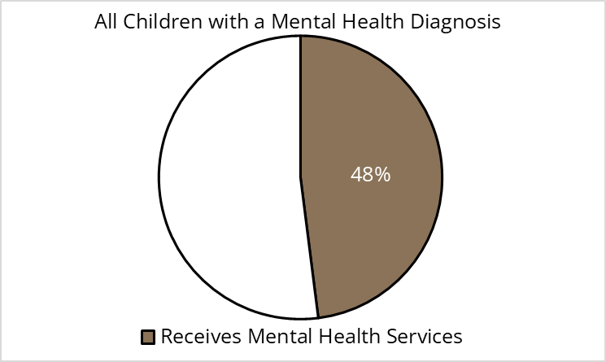

**2.1 Percentage of TN Children with a Mental Health Diagnosis Receiving Mental Health Services**

**2.2 Mental Health Service Use Among TN Children with Depression, Anxiety, ADHD/ADD, or Autism**

When rates of receiving mental health services are broken down by diagnosis, a majority of TN parents polled who have a child diagnosed with Depression or Anxiety report their child was receiving services for these conditions. Less than half of children with an ADHD diagnosis were reported to be receiving services. For children with Autism Spectrum Disorder (ASD), only one in three parents report that their child was receiving services.

**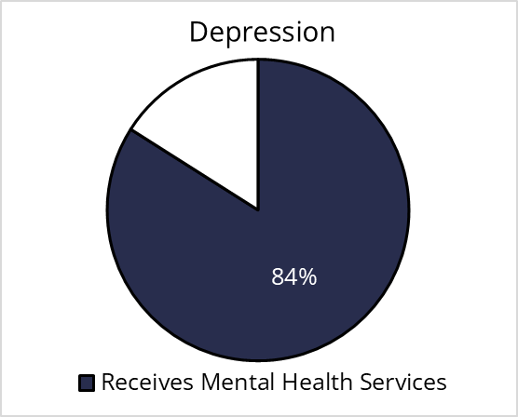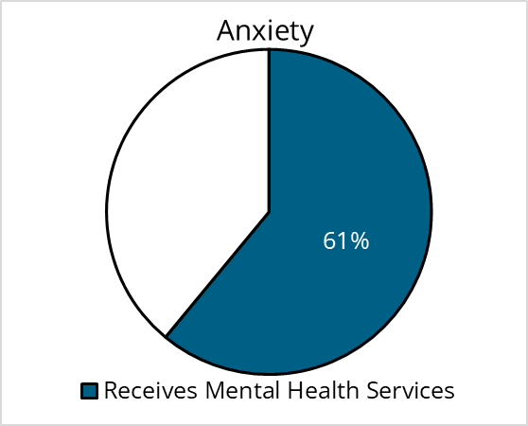  
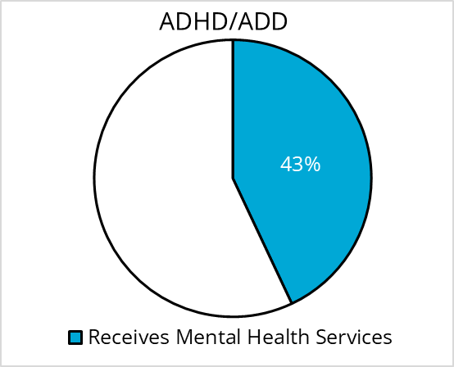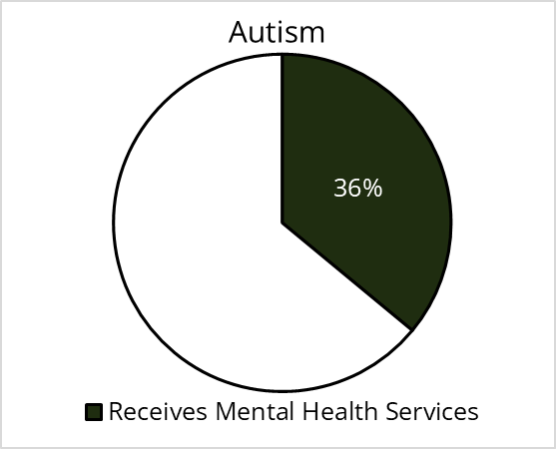  
  
2.2 Mental Health Service Use Among TN Children with Depression, Anxiety, ADHD/ADD, or Autism**

**SECTION 3. SCHOOL-BASED MENTAL HEALTH SERVICE USE**

**3.1 Trend in School-Based Mental Health Service Use Among TN children Receiving Mental Health Services**

There has been a significant decline in school-based mental health service use in children since 2022 and 2023. In 2024, Tennessee sought to ensure that parents consented to and were aware of any contact a child had with school counselors. School counselors often act as initial points of screening for potential referrals to mental health services.

**, Picture  
  
3.1 Trend in School-Based Mental Health Service Use Among TN Children Receiving Mental Health Services**

**SECTION 4. ABOUT THE VANDERBILT CHILD HEALTH POLL**

**Background.** The Department of Pediatrics and the Monroe Carell Jr. Children’s Hospital at Vanderbilt University Medical Center are committed to improving the health and wellbeing of children, adolescents, and their families throughout Tennessee. One way we accomplish this goal is through connecting with the public to better understand the concerns of Tennessee parents about the health of their children and the health care services they receive. To this end, we have conducted an annual child health poll of Tennessee parents in collaboration with Ipsos Public Affairs (Ipsos) since 2019.

**Population Sampled.** The poll was conducted on KnowledgePanel®, a probability-based web panel designed to be representative of the United States, supplemented with additional interviews using online (opt-in) panels other than KnowledgePanel, to maximize the overall sample size. The target population consisted of parents in Tennessee with at least one child under the age of 18 who lives in the household. Selected KnowledgePanel members received an email invitation to complete the survey and were asked to do so at their earliest convenience; various methods were used to contact respondents for the other online panels.

The 2024 poll was fielded between December 6 and December 31, 2024. A total of 1,180 participants responded to the poll (median completion time was 12.4 minutes). 158 cases were terminated for eligibility reasons (e.g., non-resident of Tennessee, not a parent, age < 18 years). 14 additional cases were excluded due to data quality issues, resulting in a final completed survey sample of 1,008 (85% of total respondents).

**Response Weighting.** Once all data are collected and processed, study-specific design weights are adjusted to account for any differential nonresponse that may have occurred. Depending on the specific target population for a given study, geodemographic distributions for the corresponding population are obtained from the CPS, the U.S. Census Bureau’s American Community Survey (ACS), or in certain instances from the weighted KnowledgePanel profile data. For this purpose, an iterative proportional fitting (raking) procedure is used to produce the final weights. The resulting weights are then scaled to aggregate to the total sample size of all eligible respondents.

For this study, benchmark distributions of Tennessee adults age 18 and over from the 2022 ACS were used for the raking adjustment of weights. Starting with a weight of 1.0 for both KnowledgePanel and other panel qualified cases, respondents were weighted to represent parents of 0-17 year-old children from Tennessee, using the ACS 2022 benchmark data.

**Design Limitations.** All forms of public opinion research are subject to unmeasured error that cannot be eliminated. When a probability-based panel like KnowledgePanel is used, Ipsos employs the total survey error approach to identify and minimize error due to coverage error, sampling error, nonresponse error, measurement error, and data processing and editing error.