**Table of Contents – Release 3**

**SECTION 1. FIREARM OWNERSHIP (Pg 2)**

* 1. Firearm Ownership Among TN Parents by Race and Ethnicity

**SECTION 2. CONCERN FOR GUN VIOLENCE (Pg 3)**

2.1Concern for Community Gun Violence

2.2 Concern for Community Gun Violence by Race and Ethnicity

2.3 Concern for Community Gun Violence by TN Region

**SECTION 3. FIREARM STORAGE (Pg 6)**

3.1 Likelihood of Participation in Secure Firearm Storage Educational Programming, Overall and by Firearm Owner Status

3.2 Support for Secure Storage Laws by Race and Ethnicity

3.3 Top Concerns About Secure Storage Laws

**SECTION 4. SCHOOL SHOOTINGS (Pg 9)**

4.1 Conversations About School Shootings by Year

4.2 Changing Schools or Homeschool due to Safety Concerns by Race/Ethnicity

**SECTION 5. ABOUT THE VANDERBILT CHILD HEALTH POLL (Pg 10)**

**SECTION 1. FIREARM OWNERSHIP**

* 1. **Firearm Ownership Among TN Parents by Race and Ethnicity**

Overall, firearm ownership in Tennessee families remains around 50% and is higher than national estimates of firearm ownership in households with children (40%). Firearm ownership among Tennessee parents has remained stable overall from 2022 to 2024. However, a decline of 12% was observed among Hispanic parents compared to previous years.

**1.1 Firearm Ownership Among TN Parents by Race and Ethnicity, 2022-24**

**SECTION 2. CONCERN FOR GUN VIOLENCE**

**2.1 Concern for Community Gun Violence**

When asked, *“how concerned are you about the impact of gun violence on the safety of children in your community”*, approximately 8 in 10 respondents (79%) reported at least some concern—ranging from a little to very concerned—about community violence highlighting the pervasiveness of this public health crisis.

**2.1 Concern for Community Gun Violence**

**2.2 Concern for Community Gun Violence by Race and Ethnicity**

While parents across all racial and ethnic groups reported concern about community violence, Black and Hispanic parents expressed this concern at disproportionately higher rates—This may reflect disproportionate exposure to violence and long-standing inequities in neighborhood safety and support.

**2.2 Concern for Community Gun Violence by Race and Ethnicity**

**2.3 Concern for Community Gun Violence by TN Region**

Concerns for community gun violence were prevalent across all three grand regions of Tennessee ranging from 76-86%76-86%), with parents from West Tennessee reporting the highest rates.s. A graph with numbers and a number of red and blue bars
**2.3 Concern for Community Gun Violence by TN Region**

**SECTION 3. FIREARM STORAGE**

**3.1 Likelihood of Participation in Secure Firearm Storage Educational Programming, Overall and by Firearm Owner Status**

Tennessee parents were asked, *“If offered, would you be likely to participate in free, community-based educational programming on secure firearm storage?”*  High levels of interest in secure firearm storage education among Tennessee parents suggests a strong desire for additional tools and resources. This was particularly true among firearm-owning parents, two-thirds of whom expressed intertest-- pointing to an opportunity to expand or strengthen outreach in this area.

**3.1 Likelihood of Participation in Secure Firearm Storage Educational Programming, Overall and by Firearm Owner Status**

**3.2 Support for Secure Storage Laws by Race and Ethnicity**

Participants were asked *“State lawmakers are considering several policies to address firearm-related injuries and deaths in Tennessee. One law being considered focuses on safe and secure storage of firearms (such as in a home or vehicle) to prevent access by children or other unauthorized individuals. To what extent do you support this type of policy?”*

Two-thirds of Tennessee parents (69%) reported supporting secure storage laws with consistent support across racial and ethnic groups.

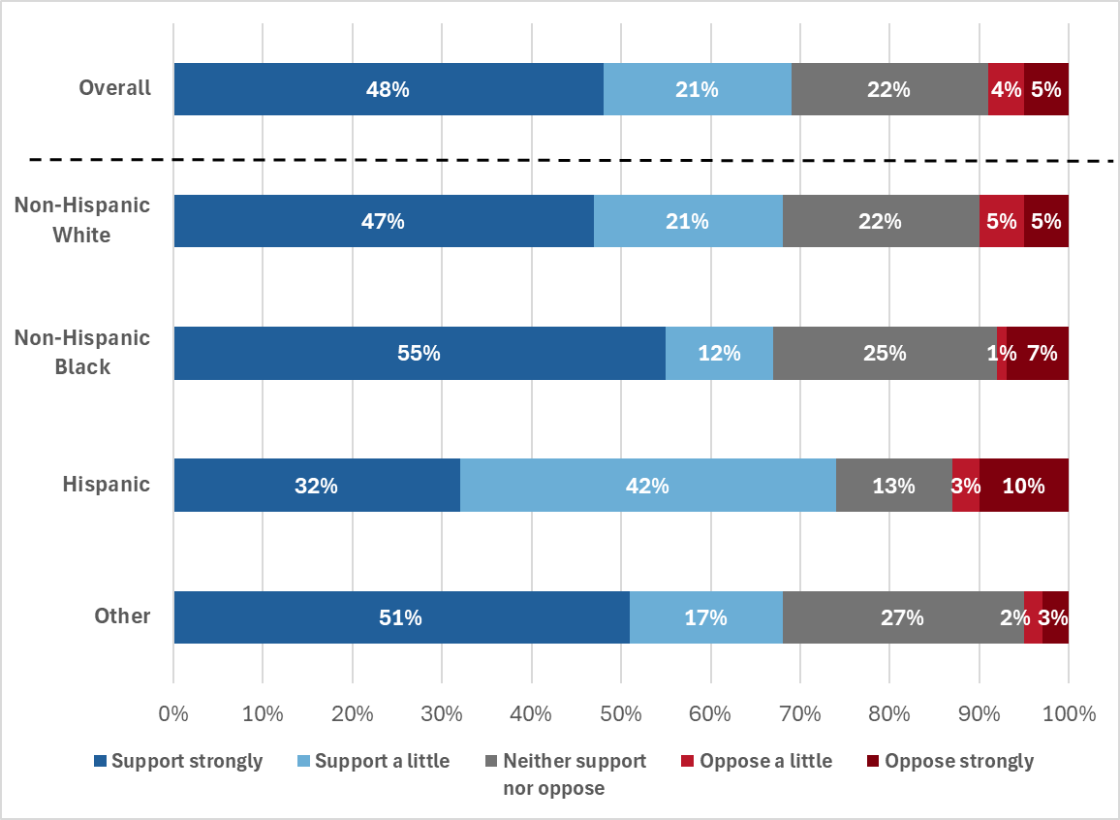

**3.2 Support for Secure Storage Laws by Race and Ethnicity**

**3.3 Top Concerns About Secure Storage Laws**

Among those who did not support secure storage laws, the primary concerns were uncertainty about effectiveness and several themes tied to implementation and enforcement. Costs of storage devices and sufficient existing laws were not commonly cited as barriers.

**3.3 Top Concerns About Secure Storage Laws**

**SECTION 4. SCHOOL SHOOTINGS**

**NOTE: For all questions about school shootings, only the respondents with a child aged 6-17 were eligible to answer.**

**4.1 Conversations About School Shootings by Year**

Parents of school age children (6-17 years) were asked, “*In the past year, have you and your child(ren) had a conversation about school shootings?”*

Over half (57%) of TN parents reported having such a conversation. Last year, it was just under two in three parents, indicating the persistence of school safety concerns.

**4.2 Changing Schools or Homeschool due to Safety Concerns by Race and Ethnicity**

Parents were asked, “*Since the last school year, have you considered changing your child(ren)’s school or beginning homeschooling due to concerns about school safety?*” Approximately one in four TN families have considered changing schools or switching to homeschooling due to safety concerns. This response comes in the context of rising mental health issues among adolescents and recent high-profile school shootings, including two in Nashville over the past two years. Non-white parents were more likely to report this concern, with the proportion of Black parents considering a school change increasing by over 50% compared to the previous year—highlighting growing differences in perceived school safety.

**4.2 Changing Schools or Homeschool due to Safety Concerns by Race/Ethnicity**

**SECTION 5. ABOUT THE VANDERBILT CHILD HEALTH POLL**

**Background.** The Department of Pediatrics and the Monroe Carell Jr. Children’s Hospital at Vanderbilt University Medical Center are committed to improving the health and wellbeing of children, adolescents, and their families throughout Tennessee. One way we accomplish this goal is through connecting with the public to better understand the concerns of Tennessee parents about the health of their children and the health care services they receive. To this end, we have conducted an annual child health poll of Tennessee parents in collaboration with Ipsos Public Affairs (Ipsos) since 2019.

**Population Sampled.** The poll was conducted on KnowledgePanel®, a probability-based web panel designed to be representative of the United States, supplemented with additional interviews using online (opt-in) panels other than KnowledgePanel, to maximize the overall sample size. The target population consisted of parents in Tennessee with at least one child under the age of 18 who lives in the household. Selected KnowledgePanel members received an email invitation to complete the survey and were asked to do so at their earliest convenience; various methods were used to contact respondents for the other online panels.

The 2024 poll was fielded between December 6 and December 31, 2024. A total of 1,180 participants responded to the poll (median completion time was 12.4 minutes). 158 cases were terminated for eligibility reasons (e.g., non-resident of Tennessee, not a parent, age < 18 years). 14 additional cases were excluded due to data quality issues, resulting in a final completed survey sample of 1,008 (85% of total respondents).

**Response Weighting.** Once all data are collected and processed, study-specific design weights are adjusted to account for any differential nonresponse that may have occurred. Depending on the specific target population for a given study, geodemographic distributions for the corresponding population are obtained from the CPS, the U.S. Census Bureau’s American Community Survey (ACS), or in certain instances from the weighted KnowledgePanel profile data. For this purpose, an iterative proportional fitting (raking) procedure is used to produce the final weights. The resulting weights are then scaled to aggregate to the total sample size of all eligible respondents.

For this study, benchmark distributions of Tennessee adults age 18 and over from the 2022 ACS were used for the raking adjustment of weights. Starting with a weight of 1.0 for both KnowledgePanel and other panel qualified cases, respondents were weighted to represent parents of 0-17 year-old children from Tennessee, using the ACS 2022 benchmark data.

**Design Limitations.** All forms of public opinion research are subject to unmeasured error that cannot be eliminated. When a probability-based panel like KnowledgePanel is used, Ipsos employs the total survey error approach to identify and minimize error due to coverage error, sampling error, nonresponse error, measurement error, and data processing and editing error.