Reviewee Instructions for the
2024 Pediatrics Annual Evaluation Survey

Introduction
The annual evaluation survey is web-based using REDCap. The survey responses from both the reviewee and evaluator will be recorded in the same survey record. These instructions will detail how the reviewee is to use the survey instrument to complete their portion of the evaluation survey. If you have technical questions concerning the use of the survey, please contact Amy Nabours (amy.nabours@vumc.org) or Carl Sanders (carl.sanders@vumc.org).
NOTE: If you are new to the department (since July 1, 2023), please use your 100 Day Plan as a starting point for your goals.
The Survey Link
The survey invitation e-mail sent to you has the link needed to access your survey. The information concerning your link is at the bottom of the e-mail message.
Please save the survey invitation e-mail. You will need the link if you need to return later to the survey.
The Survey Login
Enter your e-mail address to validate your entry into the survey.
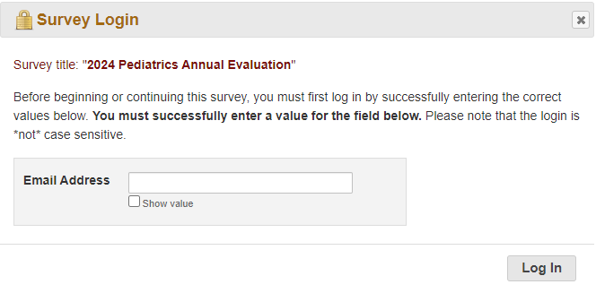

Starting the Survey
After logging in, the survey will open to Page 1 of 14 (actual length of survey may vary based on questions relevant to your track).
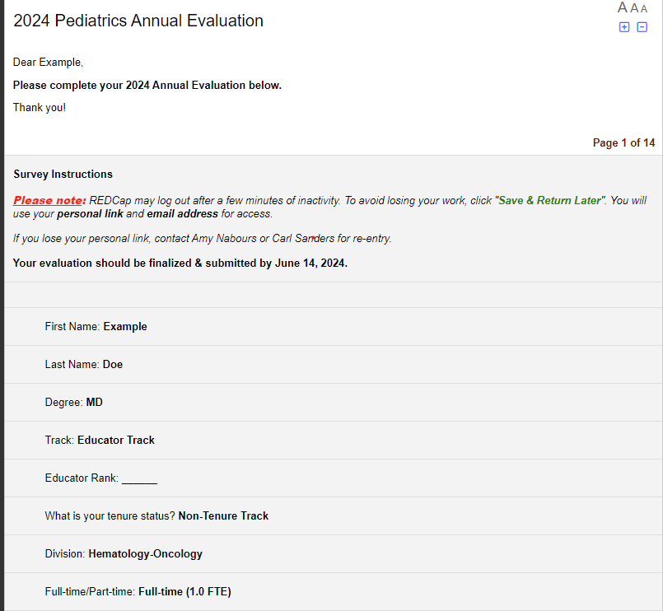
- Identifying information (such as rank, track, FTE, etc.) is displayed at the top of the survey. If any of this information needs to be updated or changed, please contact Amy Nabours at amy.nabours@vumc.org.
- Required fields have a note: *must provide value. You will not be able to advance to the next page if you have not entered a response in all the required fields.
- At the bottom of each page you will find these buttons to navigate the pages of the survey:
*See instructions below for the ‘Save & Return Later’ button.

Evaluator Questions
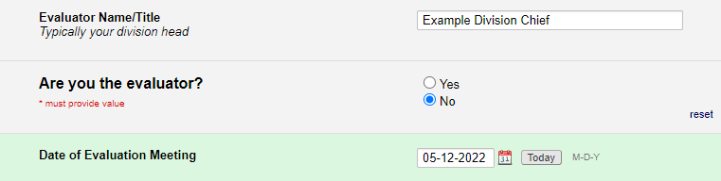
- On the first page, you will be asked to provide the name of your evaluator. This person is typically your division chief.
- Please click on ‘No’ for the “Are you the evaluator?” question. This is necessary so that you will be presented with the proper questions in the remaining sections of the evaluation survey.
Ongoing Professional Practice Evaluation (OPPE)
Please answer the following questions, if required. This question will not appear for all tracks.
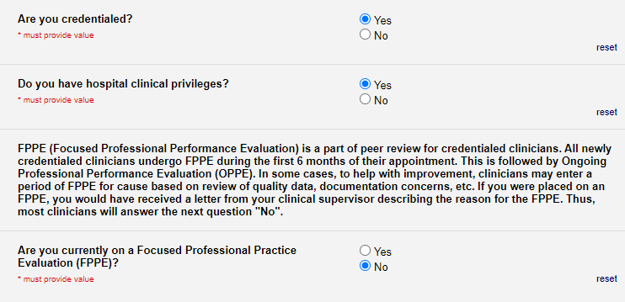
Reviewing Promotion Criteria
Please indicate that you have reviewed the promotion criteria for your faculty track, if applicable. This information should only appear for those with faculty appointments.
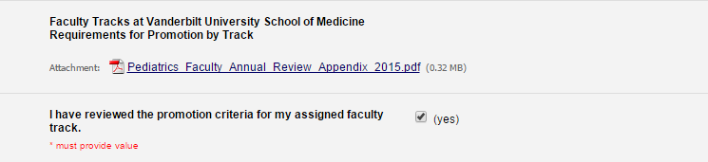
Questions for faculty NPs, PSPs, and Staff Physicians
- Promotion criteria for the Assistant in/Associate in track will be included if applicable.
- In this section, you will answer questions related to goals, professional activities, and well-being.
- You can skip to page 5 of this instruction document for information on how to save and return to the survey, uploading your CV, finishing the survey, and signing/submitting the survey.

Activity Evaluation Sections
Pages 3-8 will present a question asking whether you devoted professional activity in Clinical, Teaching, Service, Research or Administrative activities.
- Clicking on ‘Yes’ will display subsequent questions for you to complete (see below). If you click on ‘No,’ the subsequent questions will not be displayed.
- Note that last year’s goals will be displayed.
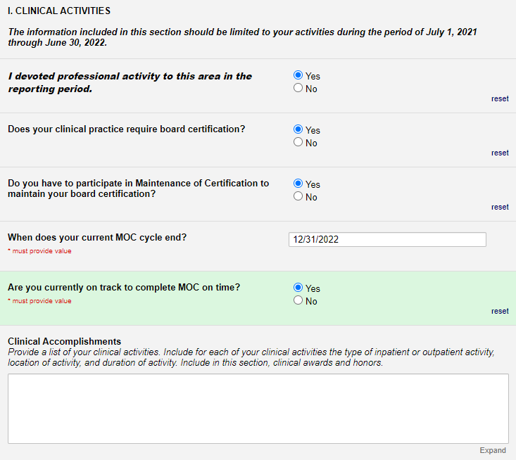
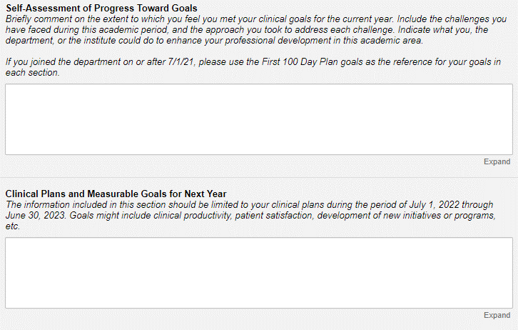
*Save & Return Later
The ‘Save & Return Later’ button will appear at the bottom of each page. You will use this button when you would like to save your work and return later to finish the evaluation survey.
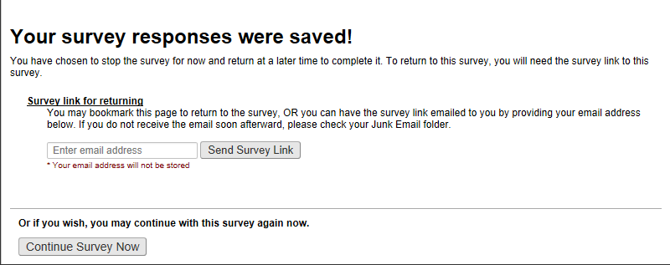
- To return to the survey, you will use the personal survey link that is e-mailed to you. This link is unique to you and should not be forwarded to others. If you do not have your personal survey link, contact Amy Nabours to receive it.
- You can close this window to exit the evaluation survey.
Returning To the Survey
After accessing the evaluation survey using your personal survey link, the following form will load:
- Enter your e-mail address and click on the ‘Log In’ button.
- You will be taken to the page in the form where you left off.
- If you experience a problem with returning to the survey, you will need to contact Amy Nabours (amy.nabours@vumc.org) or Carl Sanders (carl.sanders@vumc.org).

Uploading Your CV
On page 11, you will be asked to upload your current CV. This step is required for the survey to be completed.
- Please upload a current CV with a “last updated” date on the first page, in the required School of Medicine CV format. https://www.vumc.org/faculty/required-format-curriculum-vitae
- Clicking the ‘Upload file’ command will allow you to attach a PDF of your CV.
- After successfully uploading the CV file, you will get the following confirmation.
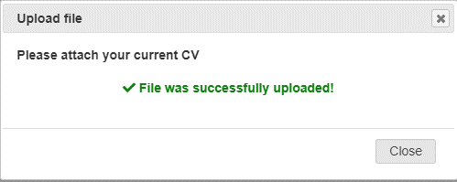
Finishing the Survey
After you have completed these steps, you will be ready to hand off the survey to the evaluator.
- Proceed to the bottom of page 12.
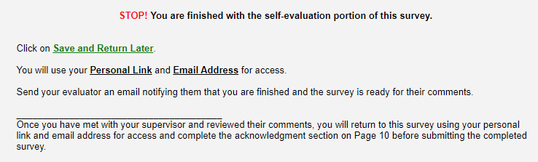
- Stop the survey at this point and do not proceed to page 13. Click on the “Save & Return Later” button.
- Notify your evaluator via email that you have completed your evaluation survey.
- Once notified, the evaluator will be able to access your survey and complete their portions of the evaluation survey instrument.

Signing and Submitting the Survey
After you have met with your supervisor/evaluator, access your evaluation survey using your personal survey link.
- On page 13, you will see a confirmation statement that says, “I have read the completed review and confirm that the contents were discussed with me.” If this is correct, click ‘Yes.’
- Under this statement, you will see a ‘Reviewee’s Signature’ box. Typing your name into this box will serve as your signature.
- Disregard the Department Chair section and advance to the next page (page 14) to click the ‘Submit’ button.
